1.select distinct pname from parts where pid in (select pid from catalog);

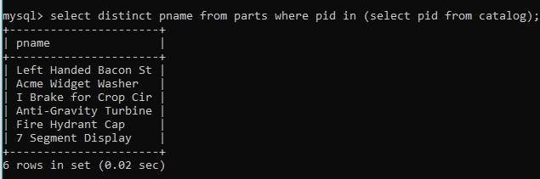

2.select sname from suppliers where sid =all(select distinct sid from catalog);



3. SELECT S.sname FROM Suppliers S WHERE NOT EXISTS (( SELECT P.pid FROM Parts P WHERE P.color = 'Red' AND NOT EXISTS( SELECT C.pid FROM Catalog C, Parts P WHERE C.sid = S.sid AND C.pid = P.pid AND P.color = 'Red' )));

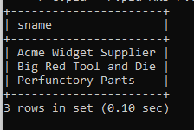

5.SELECT DISTINCT C.sid FROM Catalog C WHERE C.cost > ( SELECT AVG (C1.cost)

FROM Catalog C1 WHERE C1.pid = C.pid );

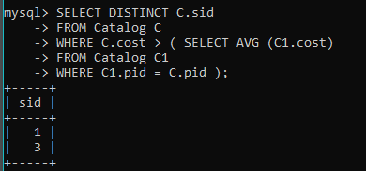

6.SELECT P.pid, S.sname FROM Parts P, Suppliers S, Catalog C WHERE C.pid = P.pid AND C.sid = S.sid AND C.cost = (SELECT MAX(C1.cost) FROM Catalog C1 WHERE C1.pid = P.pid);

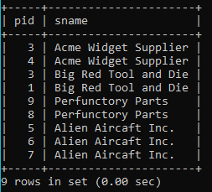

7. SELECT DISTINCT C.sid FROM Catalog C WHERE NOT EXISTS ( SELECT \* FROM Parts P WHERE P.pid = C.pid AND P.color <> 'Red' );

